

Final Report  
67373: Software Development Course

**Community Partner:** Jaren Love and Emily Stimmel

**Student Consulting Team:** Vaishnav Balaji, Mark He, Lena Li, Cindy Su

April 29, 2020

# Table of Contents

## Community Partner Background

About AACI 2

## Community Partner Project Description

Opportunity #  
 Vision #

## Project Outcomes

Insights from Background Research #  
 Website Design #  
 Website Implementation #  
 Testing and Quality Assurance #  
 Scalability and Sustainability #  
 Documentation #  
 Top Level Outcomes #

## Final Project Deliverables

Link to deployed project #

## Recommendations

Future Steps #

## About the Team

Personal Introductions #

## Appendix

1. CMS Competitive Analysis #
2. Product Feature List #
3. User Stories #
4. Project Schedule
5. Design Documentation #
6. Wireframes Low Fidelity #
7. Wireframes High Fidelity #
8. AACI Style Guide Design Documentation Updates #
9. User Testing Survey #
10. User Testing Results #
11. Deployed Mobile Screenshot #
12. Deployed Web Screenshot #

# Community Partner Background

### About AACI

The Association of American Cancer Institutes (AACI) is composed of 100 leading cancer research centers in North America, including National Cancer Institute-designated centers and academic-based cancer research programs that receive NCI support. According to its website, the AACI’s mission statement aims to promote cancer research through its dedication to

*“reducing the burden of cancer by enhancing the impact of North America’s leading academic cancer centers.”*

Given that the AACI is a relatively small organization with about 10 employees, the organization primarily shares information on its website and through annual meetings. Their members pay dues to AACI in order to share and receive information through committees such as ongoing clinical cancer research, financial, government, and leadership initiatives. Most recently, the AACI added a new public resource library with hopes to expand knowledge of current members in government relations roles, government officials, and patient advocates.

# Community Partner Project Description

In order to expand on the Public Policy Resource Library’s current collection, our team wanted to add value through a project that would enhance the current organization’s website through the design, development, and implementation of an additional webpage consisting of the federal legislation that AACI endorses. More specifically, we wanted to integrate the page with the existing public policy resource library and maintain consistency with the current library’s branding and theme. The web page would not only present static information on the legislation but also provide ‘interactive’ or ‘dynamic’ components such that viewers are able to monitor the progress of the legislation of their choice. By integrating the proposed web page with the AACI’s public policy resource library, the AACI can present a more comprehensive public policy library to its members that ultimately will engage its readership.

### Project Opportunity

In order to ultimately support the AACI’s mission to inform its audience and expand its readership, we wanted to add value and support their in-house technical department through a closer examination of the Public Policy Resource Library. Since the AACI is a smaller organization that has outsourced many of its technical work to third-party vendors, the Public Policy Resource Library currently houses limited cancer resources and policies which are often in the form of fact sheets. For this reason, there are plenty of opportunities to expand the library’s current collection that showcase legislation endorsed by AACI on the state level.

### Project Vision

Through our support of the AACI’s mission to reduce the burden of cancer by enhancing the impact of North America’s leading academic cancer centers, our team aims to ultimately enable the AACI to foster additional avenues of engagement with its members through the Public Policy Resource Library.

After listening to the needs from a meeting with the AACI, our team’s original project goal in delivering our project vision was to build a page that would enable users to track the progress of federal legislation supported by the AACI. The relevant stakeholders involved with this project include the AACI board and leadership, its technical staff, and members that may involve program steering committees. In addition, cancer center directors and public policy advocates across the nation would certainly be interested in the purposes of the public policy library, which provides them with a way to discover and become involved with the work of the AACI. Since this project involves the curation and dissemination of information, our team took the preferences of the AACI’s current IT personnel into careful consideration, as they will be responsible for updating the page and tracking progress.

In creating this dynamic page, our team is excited to contribute to this project dedicated to showcasing the current and future legislation of cancer policy, increasing reader engagement, and ultimately producing a sustainable solution that delivers upon the AACI’s mission of enhancing the impact of North America’s leading academic cancer centers through information and education.

# Project Outcomes

For this ten week project, we aimed to expand the existing Public Policy Resource Library in our client AACI’s website to develop the legislation tracker. Our new project is focused on keeping members of the AACI informed of new updates related to the legislation progress of the bills. We separated our work into two main phases, which were the design and development of the tracker. In the design phase, we conducted background research, communicated with our clients on specifications for the new product, and established the context which focuses on the end-user.

Based on feedback, we made multiple iterations of website design changes, and exchanged ideas in order to optimize the product’s features for the organization. During this time, we finalized our website design template, made preparations to extend our software development pipeline to an external developer, and passed over our design specifications. As we moved into the development phase, we communicated with the external developer rapidly through Basecamp and made minor adjustments as discussed with our clients during weekly meetings. Thereafter, we performed a condensed version of user testing due to time and people constraints but still ensured, through gathering positive feedback, that the project would be comprehensive, usable, and aesthetically pleasing.

Throughout the project, our team has recognized the importance of proactive documentation and have organized these files accordingly by user needs, design specifications, and software requirements. Future developers can reference our GitHub repository to access these materials.

### Insights from Background Research

During the ideation phase, we looked into all current available resources similar to our intended end-product and gleaned key insights to form a competitive analysis of the product landscape. Compared to similar legislation tracker websites from government or other organizations, we identified that the existing resources are less focused on extracting information, and more focused on displaying all resources and letting readers identify the important ones. We discussed this with our clients Mr. Jaren Love and Ms. Emily Stimmel, and drew the agreement that our project is more focused on information sharing on important legislation fields that are endorsed by AACI. It is less focused on delivering plain information, but rather on selected important updates that have a significant impact to the legislation status set by Jaren. We also aimed to distinguish our website from other similar products in a more visually friendly way, since it contains less information, and also be aesthetically consistent with the existing website design of our client’s organization.

### Website Design

We shared our ideas through drawing on papers and rapid prototyping tools including Invision and Figma. One key design goal was that the website page needs to be consistent with our client’s existing website design. We also tried to make the design functionally similar to the existing legislation tracker websites from the government to make the transition to our new platform easier for readers.

With this idea in mind, we made four main conceptual pages as the following:

* **Home page:** displays all bills endorsed by our client AACI in a card structure. Inside each bill on the home page, there is a link to go to the bill overview and another link to directly see the detail of the bill.
* **Bills overview page:** displays the overview of the selected bill from the home page. It also allows quick navigation towards other bills and easily views on the latest updates.
* **Bills detail page:** displays the full detail of the legislation tracking status of a certain bill. It includes a short about section, quick facts section, and the main legislation tracker.
* **About page:** displays the about information relative to our project, as well as the broader Public Policy Resource Library which our project is expanding on.

We iterated our design multiple times and exchanged opinions on all the minor details as well as the wording and color choices. Our client organization AACI has relatively strict rules on the design choices that we followed closely. The full detail of our website design is included in Appendix G.

### Website Implementation

Our client organization uses multiple platforms, designed mainly by two parties: Blue Archer, which is responsible for the main website, and Mr. Mark Busnelli, who works as an external website developer responsible for the implementation of the Public Policy Resource Library, the project we are expanding on. Since the external developer Mr. Busnelli has a contract with AACI, he is responsible for developing the website as we hand in our design prototypes. Nearly hundreds of messages were sent on several platforms, primarily on project management software Basecamp. We made further adjustments towards our design, both for practical concerns that it might take too much time, and for design concerns when Mr. Busnelli proposed some great alternatives. The finished staging website design was completed on April 20, and AACI is preparing to launch the project in the near future.

In addition, we believed it was crucial to perform some method of user testing to make sure our project delivered the desired outcomes. We first made a survey which our clients shared with the internal staff of AACI. Due to the special subject of our project as a legislation tracker of cancer related bills, and the current circumstance of COVID-19, we had limited resources to reach professionals outside of the organization. Instead, we contacted peers studying design to evaluate the aesthetic part of our design and point out if there existed any issues with usability. We discussed the feedback that we received from our friends and from our survey (see Appendix I) with our clients during the meetings. We also shared our opinions towards the feedback on Slack and updated the developer through Basecamp to ensure that our project would be usable and useful.

### Scalability and Sustainability

Due to AACI’s smaller organizational size, and the fact that Mr. Love is likely to be the sole curator in the near future, scalability was not one of the main concerns. We did not include any collapsed pages or other designs that consider a larger amount of information. Mr. Love also noted that he would most likely only be able to keep track of less than 10 bills at the same time, so we didn’t have the need to make the project scalable for explosive growth. We proposed several design elements that we shared through internal design documents with our clients in case the project becomes larger in the future.

Since our project is an expansion of an existing feature, our project can be easily sustained as both clients already have the knowledge of how to use the backend for months. Since our clients intend to keep the external developer for a long period of time, we believe that our clients and any future developers can easily understand our project and make expansions based on our various documentations.

### Documentation

We have extensive documentation on following two main objects:

* **Design of Federal Legislation Tracker:** a detailed discussion of our design choices, the design templates itself, and suggestions on any future expansions
* **Updates on the AACI Style Guide:** our suggestions for the expansions of AACI’s existing style guide to include the website portion. We not only included the general style guide for our project, but also condensed information that we observed from other web pages inside AACI’s various websites.

Since AACI intends to have a long-lasting and exclusive relationship with the external developer Mr. Busnelli for their backend needs, we are not responsible and not able to make documentation on the backend structure. However, with our current extensive documentation, we provide easily understandable documents to any future developers to expand our project. We also save the time of any future project teams to understand the current structure of the website designs.

### Top-Level Outcomes

Throughout our project, we have made new one-stop platforms mainly for AACI members to grasp the latest updates on the legislation status of bills endorsed by AACI. Learning about the latest important updates on a cancer-related bill is difficult, either because the accuracy of information decreases as it is spread through various platforms and websites, or because important updates are overwhelmed by the massive amount of non-crucial information. This expansion project saves members of AACI time to view the important updates, as it provides a one-stop shop for members to view the important updates carefully selected by AACI. Our project is also consistent with AACI’s statement to “advance the objectives of cancer centers by promoting widespread recognition of the cancer center network” by sharing the knowledge.

# Final Project Deliverables

Our final project deliverable can be accessed here.

In addition, listed in the appendix are several useful items:

* The **design documentation** for future reference
* Complete **product feature list** with level of importance
* **Screenshots** of the legislation tracker pages for the live web and mobile displays
* **Prototypes** of the website design
* The **user testing survey** including gathered results
* The project **user stories**

# Recommendations

The federal legislation tracker is now complete and running; however, it can be sustained and still improved by curating and creating additional functionalities.

To sustain the current progress of the website, our client, AACI, can populate the federal legislation tracker with more information on the legislation, and make improvements to the design of the website by understanding the responses we are gathering from the user testing survey and continuing to track user activities via CraftCMS. When we developed the current design and assisted in the implementation of the staging website, we collected some data on AACI’s endorsed legislations so that there is a sufficient amount of information on the website for user testing.

However, the legislation tracker can present more value if the curator adds more content, such as updates on the status of a bill. More content means that the website can better fulfill its purpose of being an informative one-stop shop for AACI’s stand on federal legislations. If the federal legislation tracker can establish its reputation with fuller content, it can gain more returning users who will choose and potentially advertise AACI’s legislation tracker for educational or informational purposes.

Prior to the closure of the project, we conducted user testing by distributing a survey on users’ experience with volunteers in the field of cancer research or government relations. We currently do not have enough time to conduct full-on analysis of the responses, but we have still compiled the results and made them accessible to our client for further analysis. We would also like to recommend that our client look at the responses to understand how the website’s design can further develop and improve to support better user navigation and experience in general, so that the website allows users to spend less time to get to the content and to want to return to use the website.

The federal legislation tracker can also accommodate additional functionalities to enhance the user experience. For example, we have proposed adding a search function when the number of AACI’s endorsed legislation grows large enough. In terms of the technology, CraftCMS, the current platform that hosts the legislation tracker, is able to support searching as it is already implemented in the public policy resource library. For the users, a search bar allows more efficient information retrieval. Additionally, our client can look into web crawling for the news or updates section of each legislation. Currently, the number of bills is small enough that the legislation tracker is fully manageable and maintained by human curators. If the size ever grows larger, our client can look into the application of web crawlers to scrape news from the press online to populate the content on the legislation. Adding such a component can efficiently present information from a variety of sources and requires little time from the curators.

Lastly, AACI can utilize internal marketing to introduce the federal legislation tracker properly to AACI’s stakeholders. Even though the federal legislation tracker is part of the public policy resource library and thus can be accessed from the library, it would be ideal if the federal legislation tracker can be introduced to regular AACI’s visitors through, for example, the news section of AACI’s main section.

In conclusion, the actionable items for our client are as follows:

1. To sustain the tracker, populate the website and keep the content up to date.
2. To understand users’ activities, analyze the responses from the user testing survey and continue to monitor the website possibly via analytic tools provided by CraftCMS.
3. To enable efficient information retrieval, add a search bar when the number of bills grows large
4. To enable presentation of diverse content, using web crawling for reliable sources if applicable
5. To involve regular visitors and introduce the legislation tracker individually through AACI’s main website and other means such as newsletters.

Should another Information Systems student team pick up the project or partner with AACI again, there are a few more possible components to add as extensions of the AACI public policy resource library in addition to the ones discussed previously. Early in our discussion for the scope of this project, Mr. Love and Ms. Stimmel mentioned the possibility of a letter-writing tool. The letter-writing tool is supposed to provide users with a way to demonstrate support for specific initiatives or legislation. The functionality currently does exist on AACI’s main website; however, it is hosted on a different platform and leads to an external link, causing more disjointedness since the main AACI website and the public policy resource library are already hosted differently. Although we eventually did not include the letter-writing tool in our scope, it could be a nice addition to the legislation tracker and replace the current “Take Action” button on the details page of the legislation tracker.

In terms of the additional components aforementioned, technology-wise, the team may need to have expertise in CraftCMS, to check documentation from last year’s Public Policy Resource Library to implement a search function, and to look into a web crawling application with the current legislation tracker. In terms of the aspect of people, the next student team can acquire assistance on the project’s scope and ideas from their community partners and on technical issues from AACI’s external Craft developer.

# 

# 

# 

# 

# 

# 

# 

# 

# 

# 

# About the team

|  |  |
| --- | --- |
| Vaishnav Balaji | Vaishnav served as the quality assurance manager and developer of the project. He oversaw and provided feedback on design and implementation decisions, as well as on user testing interviews, surveys, and communication processes. Vaishnav is a junior majoring in Information Systems, focusing on the Computing & Computer Science content areas. |
| Mark He | Mark served as the client relationship manager by regularly corresponding with the client to keep them updated and informed on the project. He also led design initiatives by creating wireframes for the legislation tracker web pages. Mark is a junior majoring in Information Systems with a double major in Human-Computer Interaction. |
| Lena Li | Lena served as the project manager and designer of the project. She led discussions during client meetings by presenting ideas and gathering feedback. She also used design tools to create and update wireframes for the legislation tracker web pages. Lena is a junior majoring in Information Systems with a double major in Human-Computer Interaction. |
| Cindy Su | Cindy served as the client transition manager and developer of the project. She worked with the client to discuss long-term goals and feasibility of the project, and established a rapport with the client’s third-party developer by scheduling frequent meetings. Cindy is a junior majoring in Information Systems with a minor in Computer Science. |

# 

# Appendix

|  |
| --- |
| Contents |

## Planning

1. CMS Competitive Analysis 12
2. Product Feature List 13
3. User Stories 15
4. Project Schedule 16

## Design

1. Design Documentation 19
2. Wireframes Low Fidelity 20
3. Wireframes High Fidelity 21

## Development

1. AACI Style Guide Design Documentation Updates 27

## Testing

1. User Testing Survey 28
2. User Testing Results 31

## Final Product

1. Deployed Mobile Screenshot 33
2. Deployed Web Screenshot 35

____________________________________________________________________________

### 

# Planning

### Competitive Analysis

|  |  |  |
| --- | --- | --- |
|  | **Craft** | **Squarespace** |
| **Hosting** | 3rd party hosting | Built-in hosting |
| **Ease of use (admin)** | Admin can access a dashboard to edit the content. Training on how to use Craft available on the internet | Admin can edit the content in-place on the website. Usage designed to be intuitive. |
| **Development and Maintainability** | Log into Craft dashboard; Develop with Twig. Should be maintained by third-party developers if there is no technical staff in-house.  Supports plugins and third-party apps | Login as admin; Mostly drag-and-drop. Can be maintained by non-technical staff. Do not support plugins or third-party apps |
| **Costs** | Variable | $26 per month for your site (annual plan $18/month) |
| **Feasibility** | Requires learning of Craft 3. Requires learning of Twig, the language associated with Craft. | Requires little learning. |
| **Scalability (data/information)** | Can support complex information structure and complex backend design | Has simple back-end design. Might not support complex back-end design (i.e. information storage) |

### 

### Product Feature List

The product feature key has been defined according to last year’s (2019) AACI student group.

|  |  |
| --- | --- |
| **MVP** | refers to the "Minimum Viable Product". This version would contain the minimum necessary features to satisfy the needs of the users and address the core value of the project. E.g. application must be able to host documents internally about cancer legislation. Features labeled as "MVP" are priorities for this version of the project. |
| **Nice To Have** | refers to features that help improve the user experience but are not absolutely essential to the core purpose of the proposed resource library. E.g. ability to download a template and examples for public commenting is convenient for users but more of an added benefit. Nice To Have features are implemented only after MVP features have been successfully created. |
| **Gold Plating** | refers to features that will be added only after MVP and Nice To Have features are successfully implemented and if there is time. For example, sharing to social media is not a necessity, but would be a good feature. |

|  |  |  |
| --- | --- | --- |
| **Category** | **Feature** | **Need** |
| Navigation | *Link from Public Policy Library Home Page* | **MVP** |
| *Click for Quick Overview* | **Nice to Have** |
| *Click for Full Details* | **MVP** |
| *Take Action Button* | **Nice to Have** |
| Usability | *Headlines of bills present* | **MVP** |
| *Summary of bill information* | **Nice to Have** |
| *Date of latest update* | **MVP** |
| *Pending and Passed Bill* | **Nice to Have** |
| *Timeline of bill information* | **MVP** |
| *Quick Facts information* | **MVP** |
| *Automated letter PDF generation* | **Gold Plating** |
| Design | *Mobile Responsive* | **MVP** |
| *Consistent Branding with Parent Website* | **MVP** |
| *Metrics to track engagement of certain bills/issues* | **Gold Plating** |
| Security | *System Admin Login* | **MVP** |
| *Content Editor Login* | **MVP** |
| *Member Login* | **Gold Plating** |

### User Stories

|  |  |  |  |
| --- | --- | --- | --- |
| **As a <type of user>** | **I want <some goal>** | **So that <some reason>** | **Priority** |
| AACI member | To view the current federal legislation requirements | I can understand the steps I need to follow and understand the process easily on this website. | **MVP** |
| Government relations director | To read relevant federal Bills and Acts related to cancer research institutions | I can get educated about the policies already made | **MVP** |
| Patient advocate | To check how many sponsors there are for a particular federal legislation | I can understand if the group that I am advocating for has gained enough attention on the federal level | **Gold Plating** |
| Researchers | To read the legislations that AACI endorses | I can understand what AACI endorses and the benefits of partnering with AACI | **Nice to Have** |
| AACI staff | To update the page with the organization’s endorsed legislation | I can present AACI’s stand on the federal level | **MVP** |
| AACI member | To see the overview of a legislation | I can quickly understand some basic background information on legislation I am not familiar with. | **MVP** |
| AACI member | To see the development or the timeline of a legislation | I can stay up to date with the legislation I care about. | **MVP** |

### 

### Project Schedule

**Key**

**= Client Meeting**

**= Team Meeting**

**= Assignment Due**

|  |  |  |
| --- | --- | --- |
| **Task** | **Estimated Due Date** | **Notes** |
| Client Office Visit  (Canceled) | **Friday 2/7/2020** | While the team is able to make the office visit, we are aware that the meeting takes place after the submission of this assignment. Team and client bonding will take place in order to establish common ground and mutual understanding.  Note: Due to the bad weather, the client informed us that they were unable to hold the meeting. This section would be rescheduled in the next week on Monday, 2/10. |
| Team Meeting | **By Saturday 2/15/2020** | Go over team calendar and set up a routine weekly meeting time, discuss specific implementation options, develop Roles and Responsibilities |
| Client Meeting (Onsite) | **Friday 2/14/2020** | Clarify questions, both client and team should commit to the solution and implementation method. Ask what they would like to have for the sprint report assignment due the following week, and assess time needed accordingly. |
| Roles and Responsibilities | **Monday 2/17/2020** | As the team outlines roles and responsibilities, it is important to consider that each person’s role does not limit one from being there for his/her teammates should challenges come up. |
| Revised Proposal | Check peer feedback and clarify any points of confusion at least 24 hours in advance |
| Team Meeting | **By Wednesday 2/16** | Working on first Git team lab assignment |
| Team Meeting (optional) | **Friday 2/21/2020** | Finishing up Git team lab assignment |
| Git Team Lab | **Friday 2/21/2020** | Schedule time to work on the lab together in advance in order to avoid falling behind due to the tight timeline. |
| Team Meeting | **(!)Weekend of Feb. 21-23** | Given that two items are due the upcoming Monday, the team needs to devote time to work on the Sprint report and communicate with each other in time before peer evaluation submission. |
| Team Sprint Report | **Monday 2/24/2020** | Given that this is the first report, we need to position ourselves in a good place to show our commitment to and understanding of the client’s needs. |
| Peer Evaluations | Communicate any issues ahead of time in the weekend meeting before submission. |
| Client Meeting | **Tentative: 2/24/2020 after advisor meeting** | Review progress and sprint report as soon as possible in order to move onto the next item. Doughnuts are allowed. |
| Communicating technical concepts HW | **Wednesday 2/26/2020** | Given the lack of information on this assignment, there is currently no meeting set to complete this assignment. If needed, virtual Google Hangouts is possible. |
| Team Sprint report | **Monday 3/2/2020** | Consider any feedback from the previous week for improvement. |
| Client Meeting (virtual) | **Tentative: Week of 3/2 - 6** | Given that this is the last week before spring break, we will hold a shorter meeting to be sure we are in communication and staying on track. |
| Capacity building planning worksheet | **Wednesday 3/4/2020** | (!)More information needed |
| Team meeting | **Thursday 3/19/2020** | Discussion on revisions, final proposal |
| Client meeting | **Friday 3/20/2020** | Discuss wireframes and timelines |
| Team meeting | **Sunday 3/22/2020** | Given that two items are due the upcoming Monday, the team needs to devote time to work on the Sprint report and communicate with each other in time before peer evaluation submission. |
| Sprint Report Due | **Monday 3/23/2020** | Sprint Report Submission (10/10) |
| Team meeting | **Thursday 3/26/2020** | Catch up on new ways to work with remote learning and video conferencing technologies. |
| Client meeting | **Friday 3/27/2020** | Client Meeting Agenda |
| Team meeting | **Sunday 3/29/2020** | Team works on sprint report together |
| Sprint Report Due | **Monday 3/30/2020** | Sprint Report Submission (10/10) |
| Team meeting | **Thursday 4/2/2020** | Follow up with Mark Busnelli on development progress. |
| Client meeting | **Friday 4/3/2020** | Client Meeting Agenda |
| Team meeting | **Sunday 4/5/2020** | Team works on sprint report together |
| Sprint Report Due, Peer evaluations | **Monday 4/6/2020** | Sprint Report Submission (10/10) |
| Client meeting | **Friday 4/10/2020** | Client Meeting Agenda |
| Team meeting | **Sunday 4/12/2020** | Team works on sprint report together |
| Sprint Report Due | **Monday 4/13/2020** | Sprint Report Submission (10/10) |
| Outcomes HW Due | **Wednesday 4/15/2020** | Individual Submission |
| Client meeting | **Friday 4/17/2020** | Client Meeting Agenda |
| Team meeting | **Sunday 4/19/2020** | Team works on sprint report together |
| Sprint Report Due | **Monday 4/20/2020** | Sprint Report Submission (10/10) |
| Second to Last Client meeting | **Friday 4/24/2020** | Client Meeting Agenda |
| Midterm | **Wednesday 4/22/2020** |  |
| Team meeting | **Sunday 4/26/2020** | Team works on sprint report together |
| Sprint Report Due | **Monday 4/27/2020** | Sprint Report Submission (10/10) |
| Personal project reflection,  Logo and project information, executive summary, Final report, project deliverables | **Wednesday 4/29/2020 midnight** | Team collaborates remotely |
| Last Client meeting | **Friday 5/1/2020** | Client Meeting Agenda |
| Slides due | **Wednesday 5/7/2020** | Team 3 minutes, Client 7 minutes |

# 

# Design

### Design Documentation

### Our team has shared the [Legislation Tracker Design Documentation](https://docs.google.com/document/d/1pI9q5DnRgAZu_mahW-1Un1gne0FnlqWIVS8GBZZMp2c/edit?usp=sharing) which includes the following sections:

[Background](https://docs.google.com/document/d/1pI9q5DnRgAZu_mahW-1Un1gne0FnlqWIVS8GBZZMp2c/edit#heading=h.9e76yd79n46i), [Targeted Users](https://docs.google.com/document/d/1pI9q5DnRgAZu_mahW-1Un1gne0FnlqWIVS8GBZZMp2c/edit#heading=h.ydxly4g4ns6q)

[Issue with Current Trackers](https://docs.google.com/document/d/1pI9q5DnRgAZu_mahW-1Un1gne0FnlqWIVS8GBZZMp2c/edit#heading=h.sihsnzchm1iw)

[Requirements of the New Design](https://docs.google.com/document/d/1pI9q5DnRgAZu_mahW-1Un1gne0FnlqWIVS8GBZZMp2c/edit#heading=h.p7fsnzy3nxht)

[Improvements by the New Design](https://docs.google.com/document/d/1pI9q5DnRgAZu_mahW-1Un1gne0FnlqWIVS8GBZZMp2c/edit#heading=h.p0nnfhpc1npg)

[Pages Design Decisions](https://docs.google.com/document/d/1pI9q5DnRgAZu_mahW-1Un1gne0FnlqWIVS8GBZZMp2c/edit#heading=h.jl1z7jqyen2a)

[Home Page](https://docs.google.com/document/d/1pI9q5DnRgAZu_mahW-1Un1gne0FnlqWIVS8GBZZMp2c/edit#heading=h.cod1xfdx06ux)

[Overview Page](https://docs.google.com/document/d/1pI9q5DnRgAZu_mahW-1Un1gne0FnlqWIVS8GBZZMp2c/edit#heading=h.wl5qrtbksdtm)

[Full Detail Page](https://docs.google.com/document/d/1pI9q5DnRgAZu_mahW-1Un1gne0FnlqWIVS8GBZZMp2c/edit#heading=h.ss15m9k5n6h3)

[About Page](https://docs.google.com/document/d/1pI9q5DnRgAZu_mahW-1Un1gne0FnlqWIVS8GBZZMp2c/edit#heading=h.4pyv2i62nifu)

[Low-fi Wireframe](https://docs.google.com/document/d/1pI9q5DnRgAZu_mahW-1Un1gne0FnlqWIVS8GBZZMp2c/edit#heading=h.ozmrublssov8)

[Mid/Hi Fi Wireframe - Desktop](https://docs.google.com/document/d/1pI9q5DnRgAZu_mahW-1Un1gne0FnlqWIVS8GBZZMp2c/edit#heading=h.qbwlltabo5zv)

[Mid/Hi Fi Wireframe - Mobile](https://docs.google.com/document/d/1pI9q5DnRgAZu_mahW-1Un1gne0FnlqWIVS8GBZZMp2c/edit#heading=h.bhu9p7a6ytgk)

### 

### Wireframes Low Fidelity

### 

### 

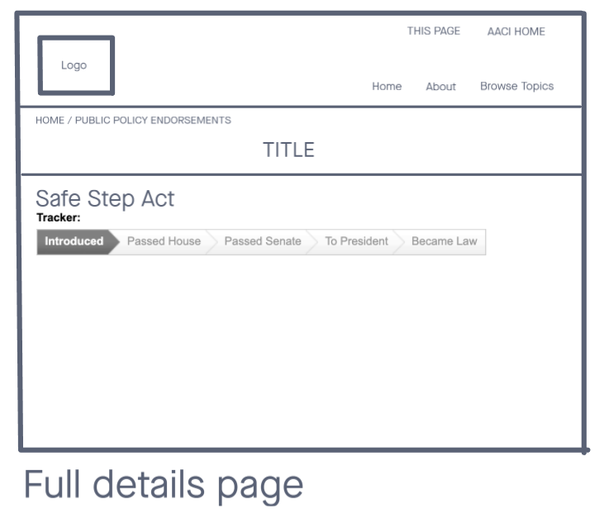

### Wireframes High Fidelity

Homepage Design A

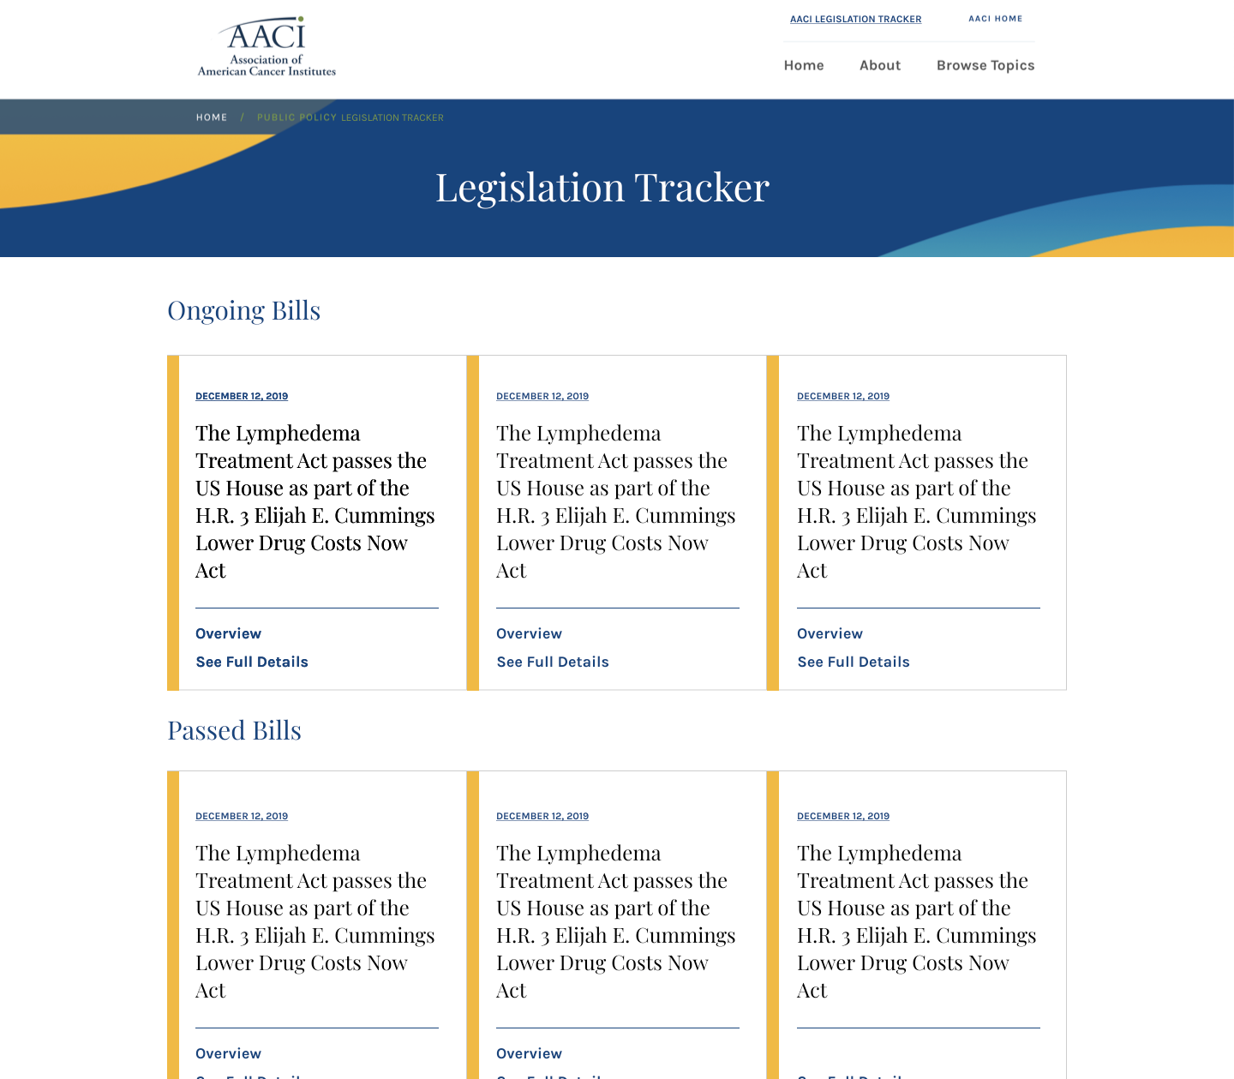

Homepage Design B

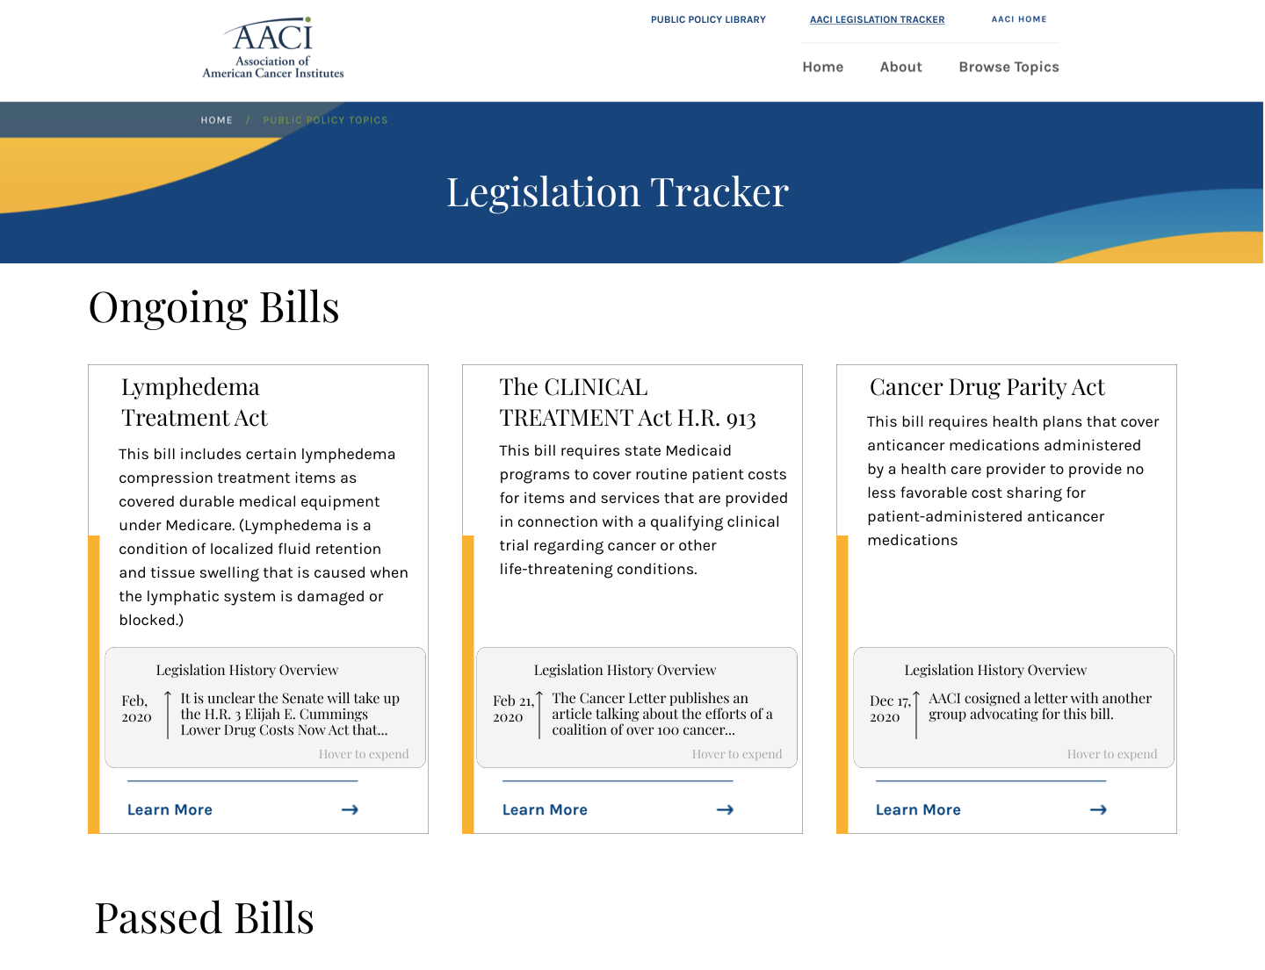

Quick Overview Page Design A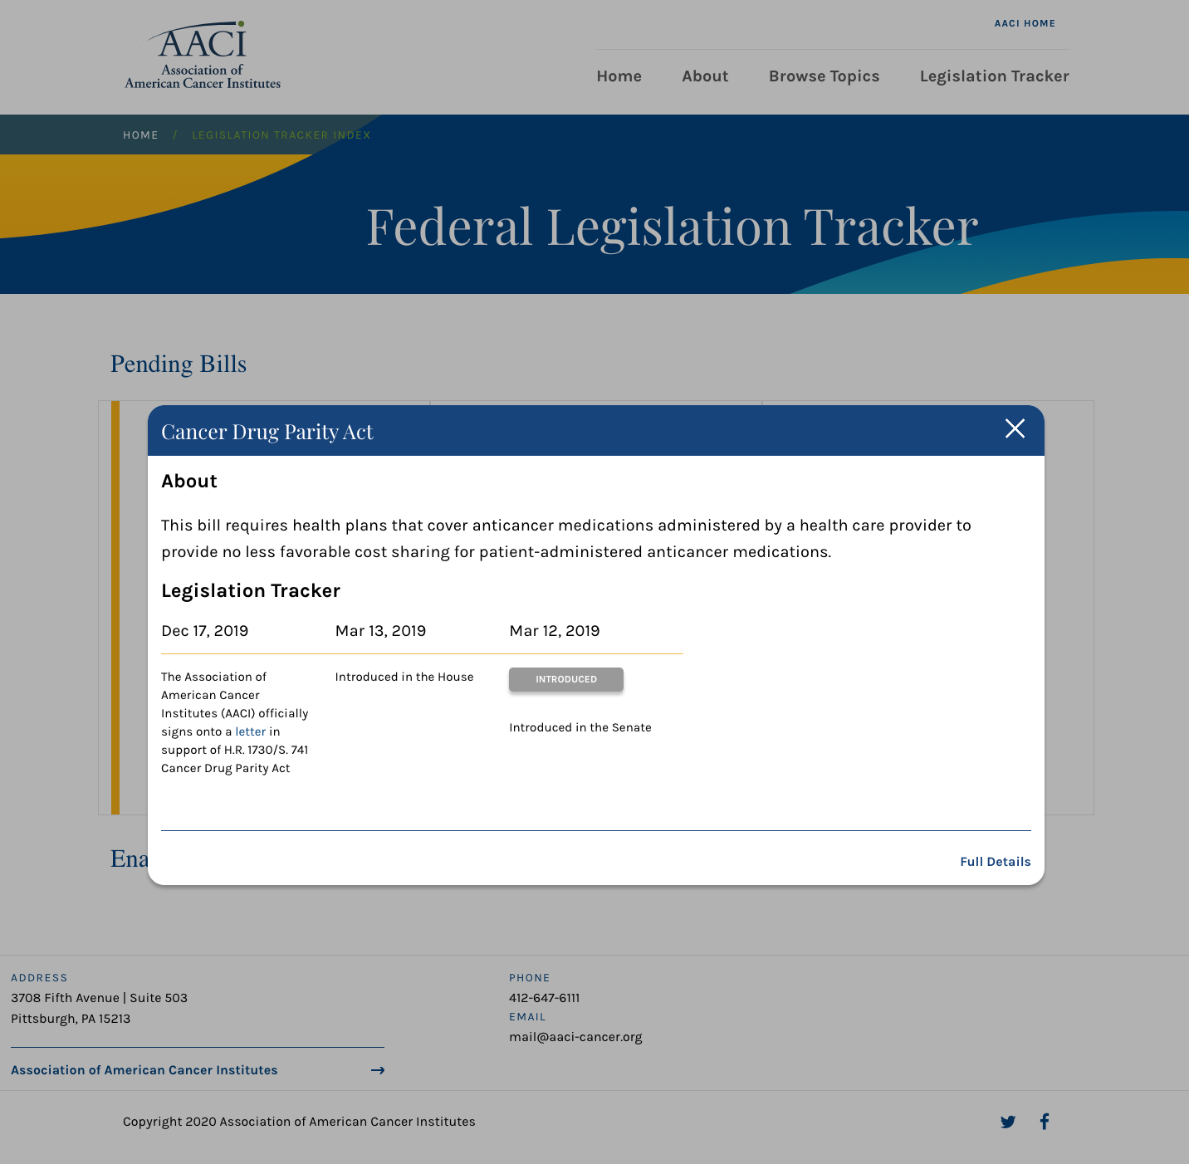

Quick Overview Page Design B

### 

Full Details Page A

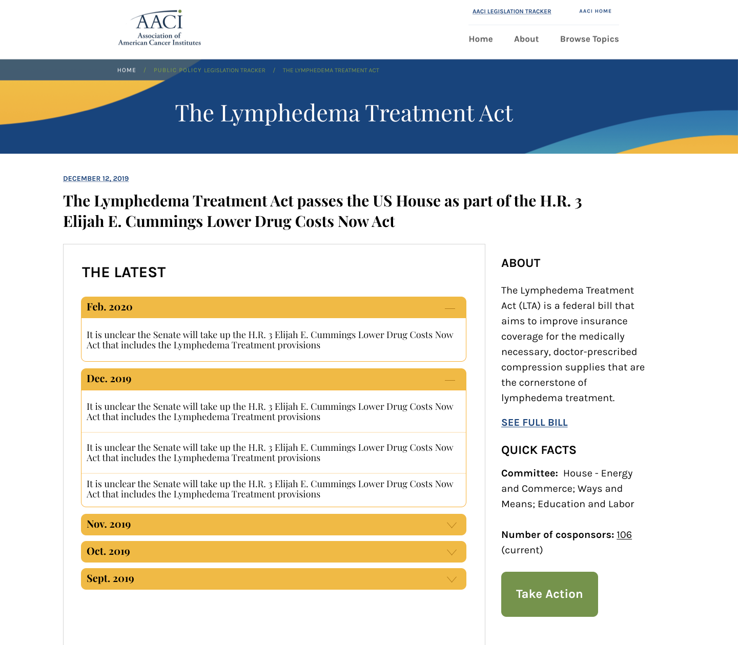

Full Details Page

Mobile Wireframes  
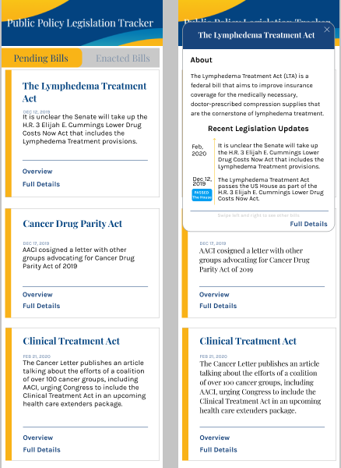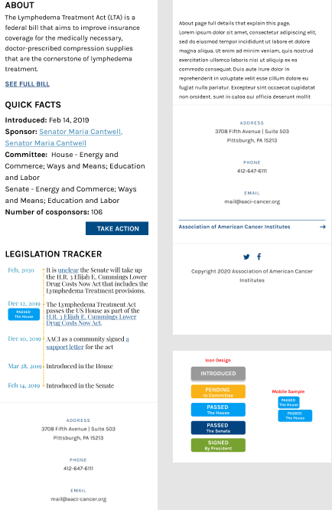

# Development

### AACI Style Guide Design Documentation Updates

|  |
| --- |
| Notes on the AACI Website Design |
| Development Teams |
| General Design Rules |
| Website Color Choices |
| Website Design Choices |
| Frequently Used Design Patterns |

The style update intends to create a basic guideline for any future website developer for AACI. Detailed materials can be viewed through the deliverables.

# Testing

### User Testing Survey

### 

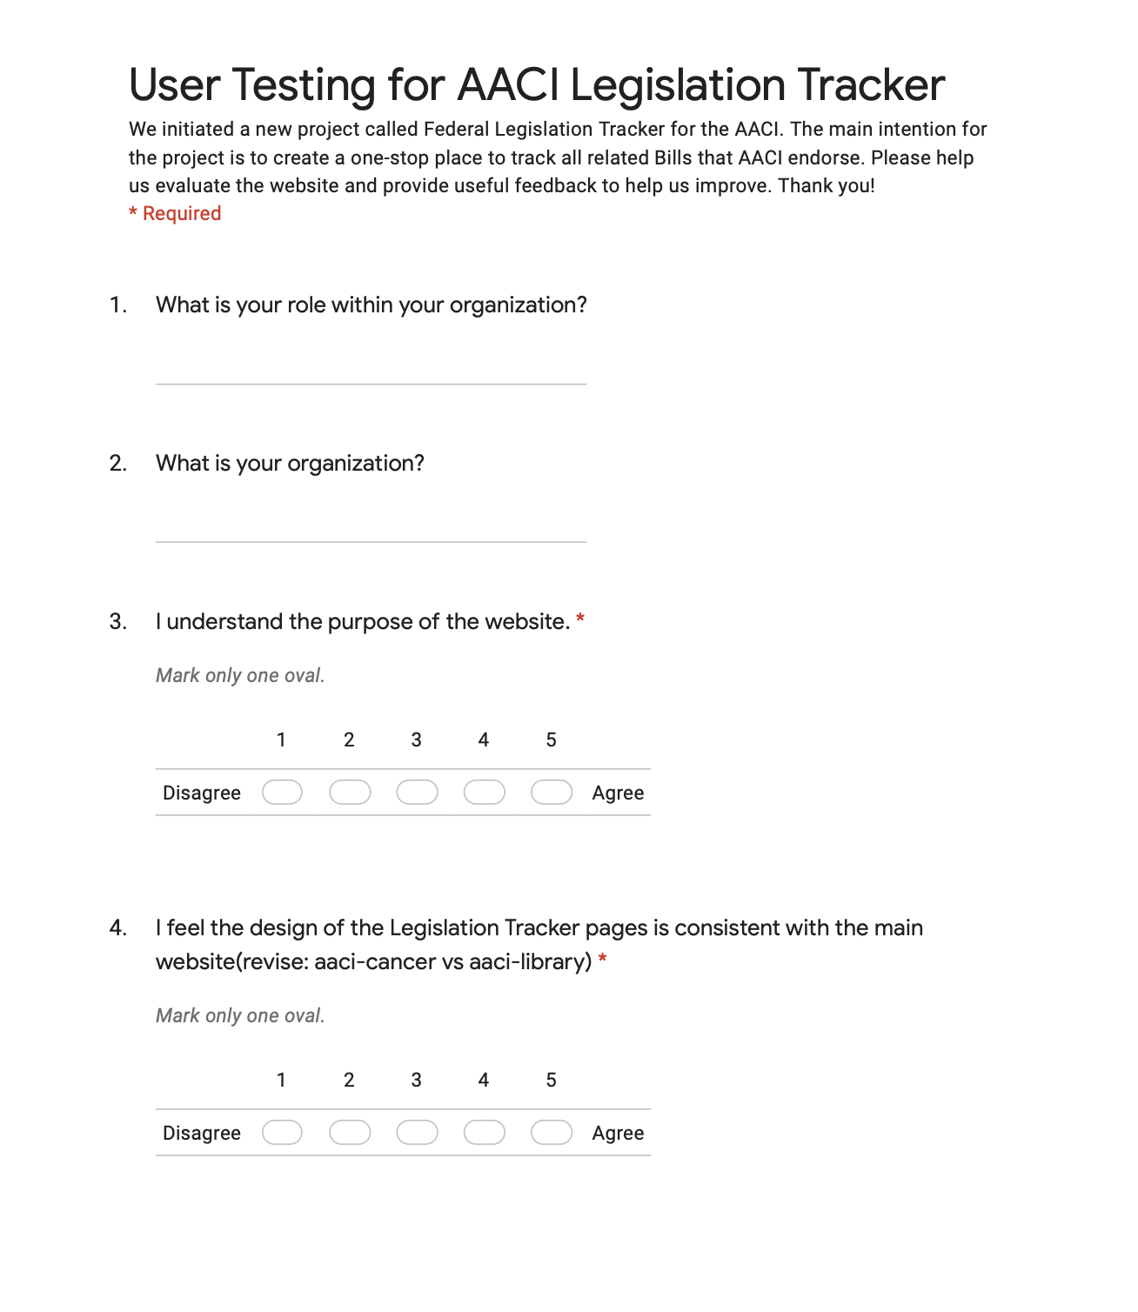

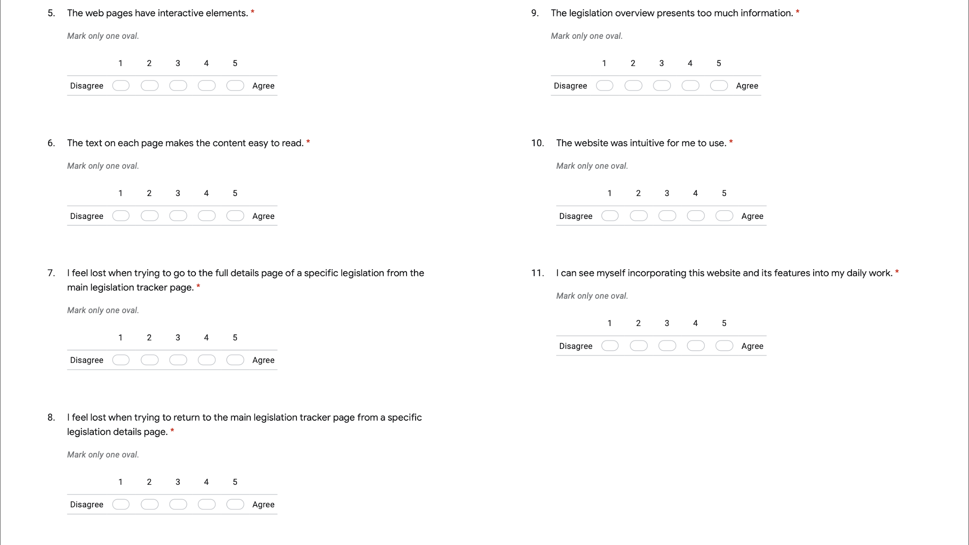

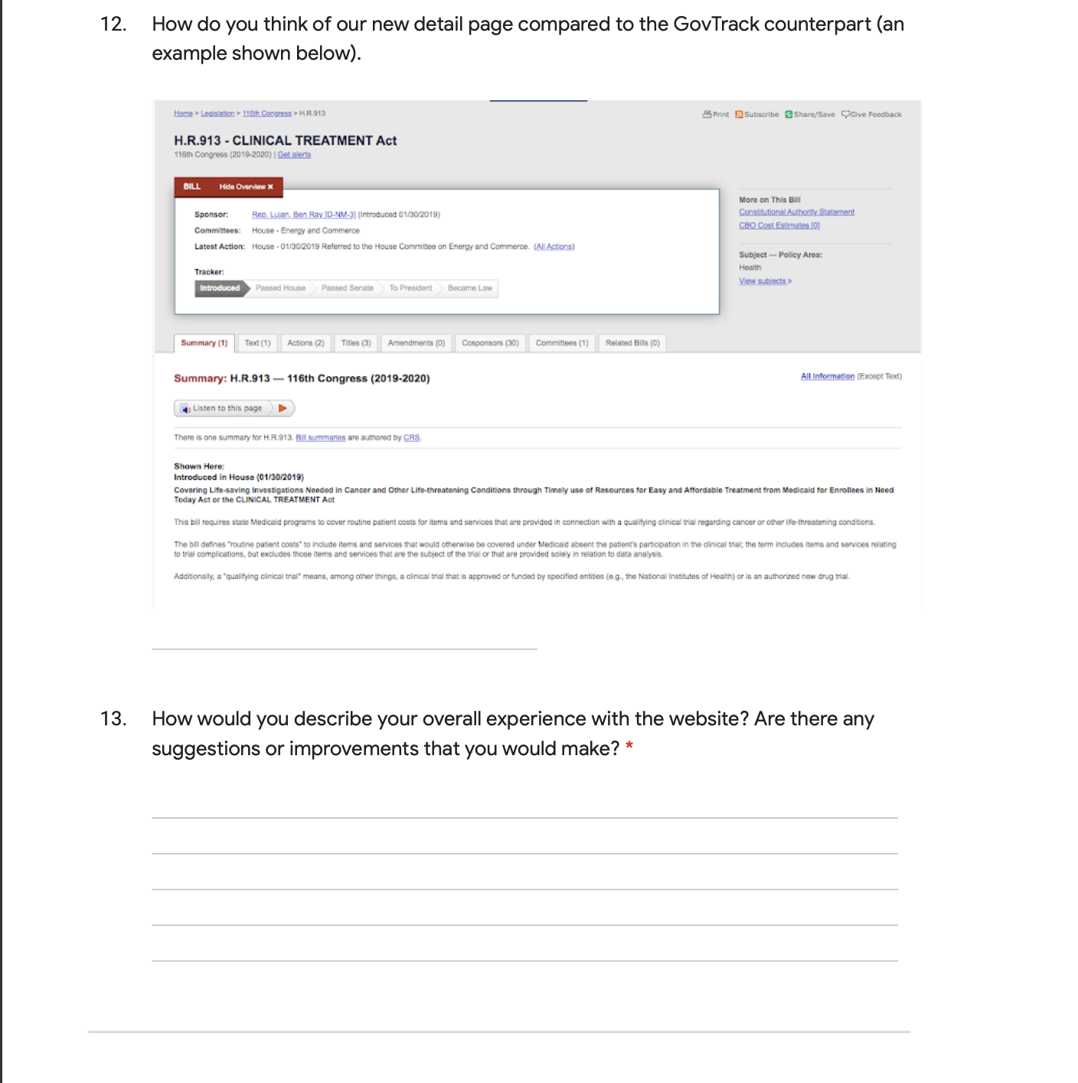

### User Testing Results

|  |  |
| --- | --- |
| Summary of User Testing Feedback | |
| Purpose | Most people understand the purpose of the website, and the contents are mostly easy to read for them. |
| Navigation | Feel lost trying to go back  The navigation on the nav bar is still mildly confusing. |
| Content Presentation | Content density  The overview content has mixed feedback, where some people think it's too much, some think okay.  The size of fonts can be adjusted and can try multiple smaller fonts before the final release. |
| GovTrack Comparison | Comparing to GovTrack  Some people really like it  One response note on the confusion of the ordering of the timeline. Specifically mentioning the up to bottom in chronological order which is more consistent with the current gov track design. |
| Other | The overview does not function with one response  One response confuses the highlight tags we have with a button. They assume the “Introduced” is a clickable box to another link or website.  One response notes the ordering of the timeline. “However, the consistency of the order of things needs to be fixed and I think chronological order should go left to right. And, top to bottom.” This seems to be one of the largest issues this response is not satisfied with. |

Selected Screenshots of the Free Response Questions

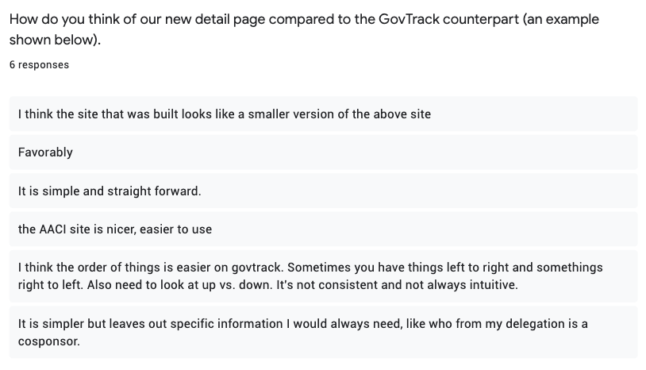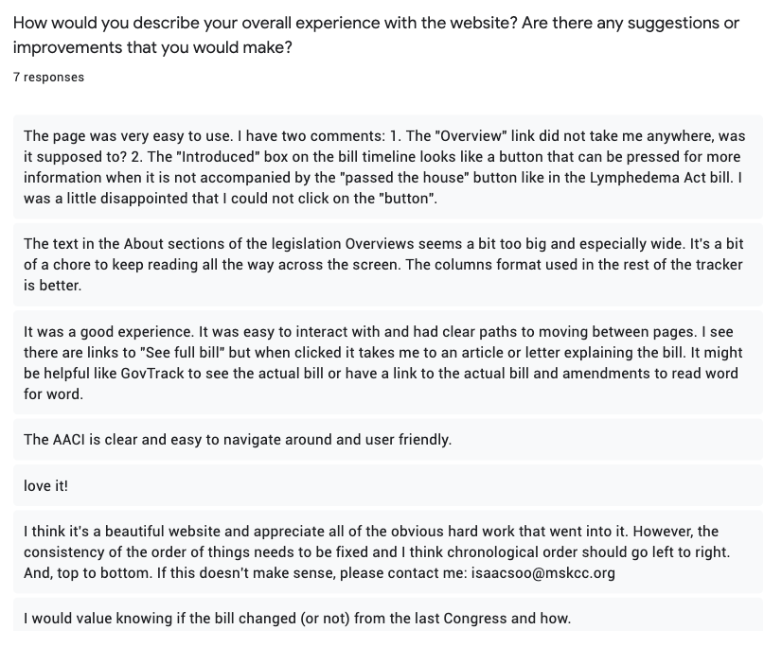

# Final Product

### Deployed Mobile Screenshot

Mobile Legislation Tracker Home Page Mobile Individual Legislation Overview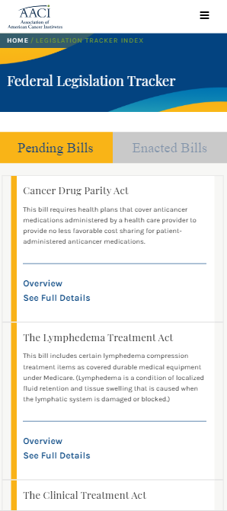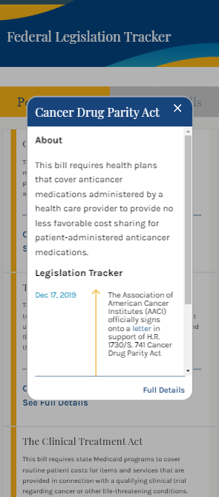

Mobile Individual Legislation Full Details Full Details, continued

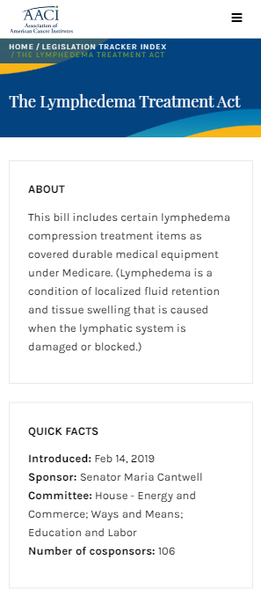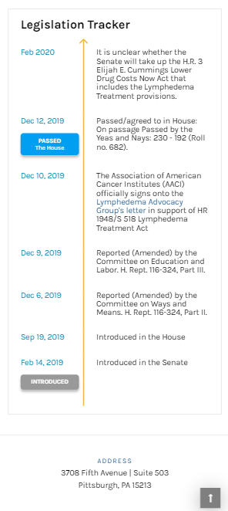

### Deployed Web Screenshot

Home Page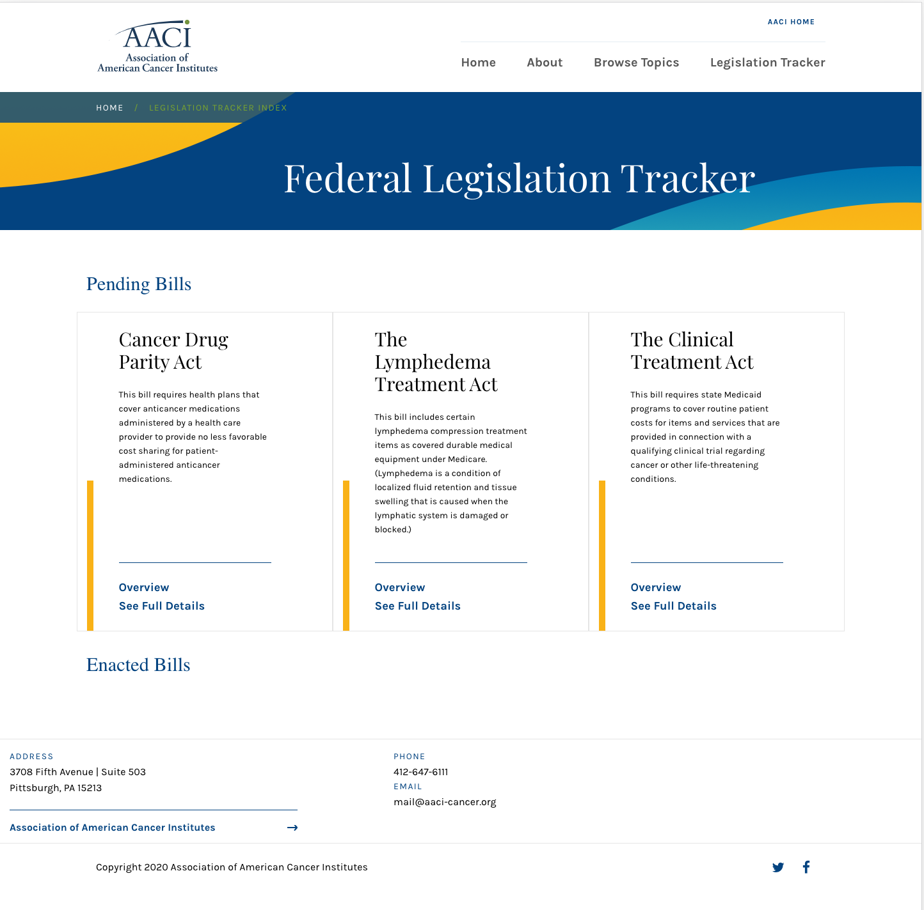

Individual Legislation Overview Page

### 

Individual Legislation Full Details Page

### 

### 

### 